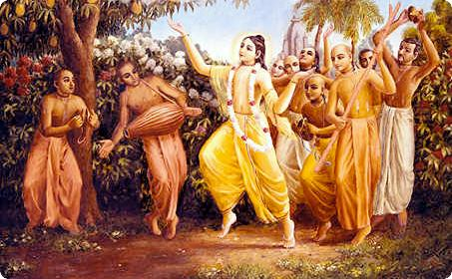
Soldiers of Godhead
July 2011 Edition
www.soldiersofgodhead.yolasite.com
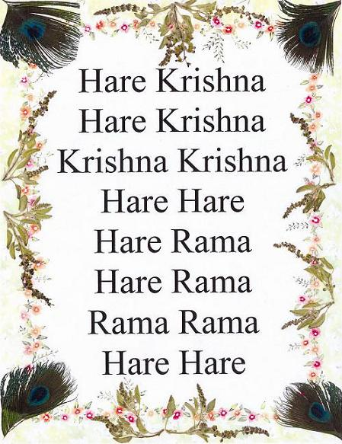
Chant Hare Krishna and be happy!
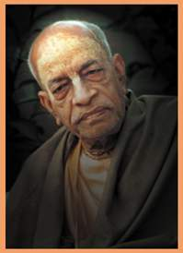
Dedicated to
His Divine Grace A.C Bhaktivedanta Swami Prabhupada- Founder Acharya of the International Society for Krishna Consciousness.
Contents
Sr.no Topic Page no.
- Offences while chanting the
Holy names of Krishna. 6.

- Where is this World Going? 11.

- The goal of life is laziness. 17.

- God is God and Dog is Dog. 23.

- The Reason Why Krishna does not immediately reciprocates. 31.

- How to Offer Bhoga? 34.

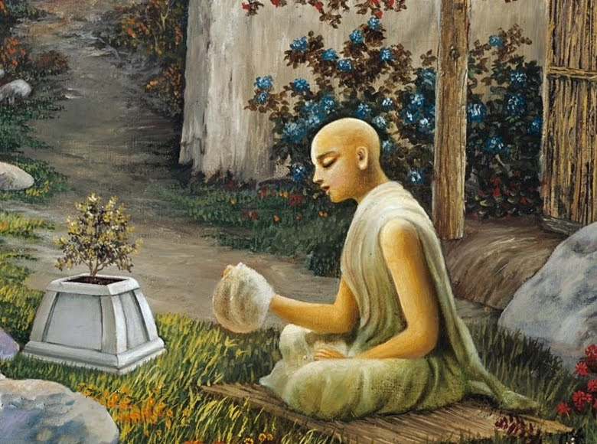

- Offences while chanting the Holy names of Krishna.
The Brhad Naradiya Purana states- harer nama harer nama harer namaivam kevalam kalau nasty eva nasty eva nasty eva gatir anyatha “Only by chanting the holy names of Lord Hari, Only by chanting the holy names of Lord Hari, only by chanting the holy names of Lord Hari can one achieve perfection in Kali Yuga. There is no other way, there is no other way, there is no other way.”
It is further stated in Kali Santarna Upanishad-
Hare Krishna Hare Krishna Krishna Krishna Hare Hare
Hare Rama Hare Rama Rama Rama Hare Hare
iti sodashakam namnam
kali kalmasha nashnam
nataha parataropaya
sarva vedeshu drishyate
“By chanting the sixteen words Hare Krishna Hare Krishna Krishna Krishna Hare Hare /Hare Rama Hare Rama Rama Rama Hare Hare all ill effects of the age of Kali are destroyed. No other method is to be found in all Vedic scriptures.”
Thus, we can understand from the above the significance of chanting the Hare Krishna Maha Mantra. When Lord Sri Krishna incarnated as Lord Chaitanya Mahaprabhu in 15th century AD at Navadwip, West Bengal, India, He preached the chanting of the Hare Krishna Maha Mantra and inaugurated the Harinam Sankirtan Movement which is today more popularly known as the Hare Krishna Movement. Lord Krishna is the Supreme Absolute Truth. Therefore there is no distinction between Him and His names, forms, qualities and pastimes. Everything directly or indirectly related to Krishna is also Krishna! Therefore the transcendental names of Krishna are also Krishna Himself. There is no difference between Lord Krishna and His holy names. Hence simply by chanting the holy names of Lord Krishna, we can personally associate with Krishna through the transcendental sound vibrations of His holy names.
Although, the method of approaching Krishna and developing love and devotion for Him is very simple, sublime, inexpensive and quick, we must guard against certain offences which can jeopardize our spiritual life if committed knowingly or unknowingly. Following are the offences to be avoided in all circumstances and especially while chanting the holy names of Lord Krishna-
- To blaspheme devotees of Lord Krishna who are engaged in spreading the holy names of the Lord around the world.
- To consider the spiritual master as an ordinary person.
- To consider names of demigods and even those of Brahma and Siva to be equal to the Holy names of Lord Krishna.
- To disregard the authority and authenticity of Vedic Scriptures.
- To consider the glories of the Holy names of Lord Krishna to be mere exaggerations.
- To concoct theories about the Holy names of Lord Krishna.
- To consider chanting the Holy names of Lord Krishna to be another ritualistic form of worship.
- To commit sins on the strength of the Holy names.
- To instruct the glories of the Holy names of Lord Krishna to faithless persons.
- To maintain material attachments even after chanting the Holy names of Lord Krishna.
Apart from the above we must also guard against the following while chanting on the Japa beads:-
- Touching the beads with the index finger.
- Touching the beads with the left hand.
- Placing the beads or bead bag on the floor or in contact with the leg.
- Skipping beads while chanting.
- Crossing the head bead while chanting.
- Improper pronunciation of the Hare Krishna Maha Mantra while chanting.
- Chanting other mantras along with or other than the Hare Krishna Maha Mantra on the Japa Mala.
- Not concentrating on the Maha Mantra while chanting and allowing the mind to wander.
- Talking to others while chanting.
- Chanting while watching television.
- Touching the Japa beads with dirty/contaminated hands.
- Placing the Japa beads in contaminated or inappropriate places.
- Chanting for showing that one is very religious.
- Chanting for fulfillment of material desires.
- Maintaining irregularity in daily chanting.
There are no hard and fast rules regarding chanting the Holy names of Lord Sri Krishna as such. Lord Krishna says in Bhagavad Gita 9.14 that one must in all circumstances with great determination chant His holy names. Lord Chaitanya Mahaprabhu says in His Sikashtaka prayers that “Oh My dear Lord Krishna it is so simple to approach You by chanting Your holy names. There are no hard and fast rules for chanting Your Holy names but yet I am so unfortunate that I have no liking towards Your Holy names.” However, one must strictly avoid the 10 principal offences- Vaishnava Aparadhs and must do his best to avoid the 14 secondary offences. This cannot be achieved overnight. One has to regularly chant the Holy names of Lord Krishna in the form of Hare Krishna Hare Krishna Krishna Krishna Hare Hare/Hare Rama Hare Rama Rama Rama Hare Hare and gradually rise to the level of offence less chanting and thereby become a fit candidate to go back home, back to Godhead.

Hare Krishna!

- Where is this World Going?
According to Vedic scriptures like Padma Purana, there are 8.4 million species of life. They consist of various life forms like trees, plants, microbes, insects, rodents, dogs, hogs, beasts, reptiles, aquatic animals, birds and ultimately human beings. Out of these 8.4 million species, 0.4 million are human species. The conditioned soul goes through these 8.4 million species birth after birth owing to entrapment in the material body, conditioning by the three modes of material nature and unending desires for material sense gratification. However, after having gone through the 8 million species of life forms, the living entity achieves the human form of life. Thus, one can understand the value of the human life form. As a human being, the living entity has superior intelligence which the other life forms are devoid of. Thus, since this human form of life is so valuable, so rarely achieved and superior in intelligence to other life forms, therefore it definitely must have a purpose. To find out that purpose is the goal of human life.
The Vedanta Sutra states-‘Athato Brahma Jigyasa’ “now that I have achieved the human form of life, let me inquire about the purpose of existence, the source of the cosmic manifestation, the supreme creator, sustainer and destroyer.” When we see a machine working but are unable to see the operator, does it mean that the machine is working independently without an operator? No. The operator is there. Otherwise how the machine is working so perfectly? Matter is never independent. It is always dependent on a spiritual force, a spiritual entity. Therefore whenever we see a car moving in a distance, but are unable to see the driver, we do not conclude that the car is moving without a driver. Rather we guess that “Yes, there must be a driver.” Similarly, the material nature is working so perfectly. The Sun is rising and setting at a fixed time, the Earth is rotating at a fixed speed, the seasons are coming and going on time etc. So if the material nature is working so perfectly and matter cannot work independently, therefore there must be someone under whose direction the material nature is working. Now, to find out who is that Supreme Person, is the purpose of human life. The living entity in the human form of life must inquire about who is that Supreme Person, and how is he related to Him. This spiritual inquiry marks the beginning of human life. In Bhagavad Gita Krishna says “mayadakshena prakrati suyate sa characharam” “It is under My direction that the material nature is working.” Therefore, Krishna is that Supreme Person under whose direction this material nature is functioning.
If one achieves the human form of life, but does not bother to make such intelligent inquires about the purpose of human life, the cause of material world, the operator of the material nature and the solution to material miseries of repeated birth, death, old age and diseases, then he is no better than an animal. Animals like cats, dogs, hogs etc live only and only for four purposes:- eating, sleeping, mating and defending. That’s all. They are devoid of intelligence and therefore they have no higher purpose of life. They live simply to satisfy their senses. But if a human being begins to behave in a similar manner, and makes no attempts to understand God, then what is the difference between a human being and an animal? Therefore it is said- dharmena heena pashuvi samana “The one who is devoid of religious principles, is as good as an animal.” Therefore, human life begins with religion and following of religious principles. To eat, sleep, have sex and to defend are not bad. They are bodily necessities and must be fulfilled in order to keep body and soul together, but they must be practiced under certain regulations. And these regulations are outlined in the religious codes of all religions and especially the Vedic Scriptures. One can regulate his eating by eating only pure vegetarian food which is first offered to Krishna (Krishna Prashadam), one can regulate his sleeping by sleeping for only 6 hours in a day instead of 8-10 hours, one can regulate sex life by having sex only and only with his/her wife/husband. Sex before marriage or outside of marriage is illicit. Defense can be regulated by protecting the weaker sections of society like women, children and elderly people and also by protecting the holy mother cow and the Brahmana community.
In the above mentioned ways, one can lead a regulated life. However, these regulations are not all in all. They are just a means to stabilize the mind and senses which are always disturbed and restless. When one’s life is regulated, then he can make inquiries about the Supreme Absolute Truth. But from whom should one inquire about the Supreme Lord? When one has a medic problem, he approaches a doctor. When one has a legal issue, he approaches a lawyer. Similarly, when one wants to know about God, then he must approach a pure devotee of the Lord. A medical practitioner cannot give legal advice and similarly, a non devotee cannot give knowledge about God. Therefore, in order to understand the Supreme Lord Krishna, we must approach a pure devotee of the Supreme Lord.
Up till a few hundred years ago, people were aware of the significance of the human form of life and they knew very well that this human life is a loop hole to cross over the ocean of repeated birth, death, old age and diseases. The living entity is eternal, full of knowledge and transcendental bliss in its natural condition. But owing to the entrapment in illusion (maya), the living entity has acquired a mortal body, he is ignorant of himself and his relation with the supreme lord, and has become sorrowful and is hankering for temporary material sense pleasures. Krishna Consciousness or pure loving devotional service to the Supreme Lord Sri Krishna is the only means of getting free from this miserable material world and to go back to the original home, back to Krishna. And in order to realize this purpose of human life, people would approach a bonafied spiritual master and render service to him and inquire about the Supreme Lord, His qualities, names, paraphernalia, associates and pastimes. The spiritual master who himself a pure devotee of the Supreme Lord would educate his disciples not merely by words but also by his actions and conduct. Thus, in the Gurukul system of education, the students would lead a regulated life, serve their spiritual master and inquire about the Supreme Lord and the spiritual master would be a role model for his disciples. Even in Administration, Politics, Military affairs, and in the day to day lives of the people, the regulative principles of religion and religious codes played a vital role and hence there was peace and prosperity in human society. However in the recent years only, this so called modern world has come up. People are leading grossly sinful lives by indulging in meat eating, intoxication, illicit sex life and gambling. Religion is seen as a stumbling block to sense gratification and hence religious codes are being violated. The education system is focused simply around the temporary material body and spiritual knowledge and well being is neglected. People are engaged in a struggle for existence. The corporate “culture” is replacing Vedic culture. People desire money, power and objects of sense gratification, but their inability to fulfill these desires leads to stress, anxiety, depression and numerous other diseases. In order to gain temporary relief from these miseries, the two legged animal called the “modern man” takes to intoxication, cinema, mundane songs, gossips and illicit sex which only increase his miseries. He does not realize that the cause of his miseries is his forgetfulness of his eternal relationship with the Supreme Lord Sri Krishna. Being devoid of religious principles, devoid of knowledge and engaged in sinful activities, the conditioned soul carries the burden of material miseries like an ass without inquiring into the cause of the misery and its solution. Being illusioned by maya and conditioned by the modes of material nature, the conditioned soul is proud of his mundane material knowledge, street smartness, strength, beauty, wealth, influence not knowing that anything and anyone associated with his temporary material body are also temporary. The foolish one takes his miseries as enjoyment and strives to accumulate what is temporary. This is the direction in which the modern day world is directed. Their motto is “work very hard and enjoy sense gratification.” Although their position is like that of goats in a slaughter house (since death can come at any moment), yet they are optimistic and refuse to accept the words of Krishna. Thus, one may ask, where is this world going?
Hare Krishna!

- The goal of life is laziness

A morning walk with His Divine Grace A.C. Bhaktivedanta Swami Prabhupada
19 October 1975, Johannesburg, South Africa
Indian man: Don't you think the people (in South Africa) are lazy?
Prabhupada: Why aren't you lazy here? It is the government's policy or government's management. You see? To become lazy is the recommendation of the shastra. "Lazy" has become a bad word, but actually real life means to not work very hard. Working hard (only) for eating means animal life, not human life. Human life should be very peaceful - without any hard work - for cultivating spiritual knowledge. Not working hard like hogs and dogs all day just to find some stool. That isn't human life. People are being educated to work very hard. That isn't human life. Therefore those who have money build a nice bungalow in a secluded place to live peacefully - to become lazy. Is it not?

Indian man: Yes.
Prabhupada: Perfection of life means ultimately you become lazy; you haven't got to work. That is perfection, they say. Otherwise why live in a cottage in a secluded place? On weekends, Americans leave aside all working. They become tired from all their hard working, and they go. The intention is to live a peaceful life, and not work very hard. That is human life. Otherwise, why go outside the city on the weekend? Why?
Indian man: They want rest, I suppose. They want rest.
Prabhupada: That means lazy.
Indian man: No. . .
Prabhupada: Yes. Rest means lazy; you don't work.
Indian man: If one works five days a week, you rest for two...
Prabhupada: That is another thing. You have to work to become lazy. (laughter) That is another thing. But the goal is to become lazy. You work five days very hard just to become lazy for two days. That's all. But if you have the means to become lazy seven days a week, you'll prefer it.
Pusta Krishna: But I think most people would go crazy if they didn't have any work.
Prabhupada: No, that means their life is not properly conducted. Therefore the word "laziness" has come (into use). "Laziness" is not actually the word. Laziness means minimizing bodily labor and engaging in spiritual work. If you ask people, "Please come to our temple," who is coming? Most people say, "I have no time." But we're not working hard.
There are (four) classifications: "Lazy intelligent, busy intelligent, lazy fool, and busy fool." So at the present moment (laughs) the whole world is full of busy fools. But the first-class man is "lazy intelligent." The second-class man is "busy intelligent." Third class means "lazy fool" and fourth class means "busy fool."
Nowadays people are busy but they're fools - like monkeys. A monkey is very busy. You see? People prefer to be a generation of monkeys, busy fools. A fool, when he is busy, is simply creating havoc. A lazy fool is better because he will not create so much harm, but a busy fool will simply create harm. And a first class-man is lazy intelligent. He knows the value of life. He's thinking soberly. Just like, you will find, all our great saintly persons. They were living in the forest, (performing) meditation, tapasya (austerity), and writing books. All lazy intelligent. They are first-class men.
Indian man: Not like the monkey, jumping from one ...
Prabhupada: What is the value of a busy fool? He is a fool, and he is busy. Nowadays, education is for making busy fools. That's all.
Indian man: What about the busy intelligent? How does he behave?
Prabhupada: Busy intelligent means at least there is some meaning to whatever he is doing. Lazy intelligent means to be doing higher things. Lazy intelligent means brahmana, and busy intelligent means kshatriya. chatur-varnyam maya srstam [Bg. 4.13]. The society should be divided into four classes. The shudras are busy fools, therefore they are to be guided. For every hundred workers, one leader must be there to give the direction: "Why are you doing this? Why you don't do this?" Otherwise they'll create havoc - busy fools. Now the whole world is full of busy fools. That's all.
For brahmanas, the Bhagavad-gita doesn't recommend, "You work hard day and night." Brahminical qualifications are controlling the senses, controlling the mind, being truthful, clean, knowing everything nicely, practical applying the knowledge, and having full faith in shastra and Bhagavan (God). [Bg. 18.42]. These things are recommended, not that a brahmana should become very busy all day and night for getting food.
Shastra says, "There is no use of becoming busy for your food. Food is there already." Food is already there. He'll get his food. That is arranged by God. But (most people) are busy fools. They don't understand God's arrangement. They're busy, day and night, like cats and dogs, only for food.
So much land is there. Everyone, if he works for two months, can grow his whole year's foodstuff. There is so much land. But no, they'll not grow food. They will grow hammers. They will manufacture tire tubes, atom bombs, then this and that. They are busy fools. They are fools, and they are very busy. Everyone is busy. There are so many parts in the motorcar, three thousand parts, and they're busy manufacturing three thousand motorcar parts. Everyone is busy producing unwanted things, and they've created a society in such a way that they have to do that.
Indian man: Otherwise they think that they not economically progressing.
Prabhupada: What is that "economical progressing?" That means busy fool. Fools don't know how to satisfy the economic problem. That is recommended in the Bhagavad-gita, annad bhavanti bhutani: [Bg. 3.14] "You grow food grains." Then all economic questions (are answered). But why aren't you producing food grains? Why you are producing iron stools and instruments and motors and tires and collecting petrol far away from Arabia? Krishna never says, "You do all this nonsense." He said, "Grow food grains." Why don't you do that? That means fools. After all, you have to eat. But you're not busy growing your food; you're busy producing tire tubes, motor cars, stools and instruments. So how you will get your food? Where is your "economic progressing?" Your first economic necessity is that you must eat.

Source: www.krishna.com

Hare Krishna!

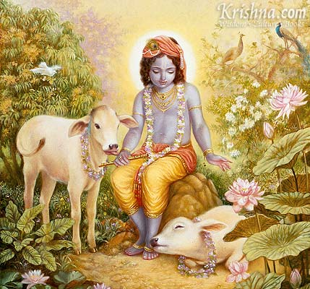
Sri Krishna
the Supreme Personality of Godhead

- God is God and Dog is Dog.
The Advaita Vedantists or mayavadis as they are called since they are followers of the doctrine of maya (illusion) which claims that the material world and all that is matter is completely false and only Brahman the Absolute Truth is reality and the living entities which are parts and parcels of the Supreme Brahman (impersonal aspect of God which is a glaring effulgence who is without any attributes) are also Brahman and therefore the individual Brahmans and the supreme Brahman are both qualitatively and quantitatively one and therefore every living being is God.
This mayavadi philosophy was spread by Sripada Adi Shankracharya through his sariraka bhashya commentaries on the Vedanta Sutra. The mayavadi philosophy is actually meant to bewilder the people of Kali Yuga and to take them away from the Supreme Personality of Godhead Sri Krishna by making them think that they themselves are God and they have forgotten their original supreme position owing to maya (illusion). But if every living being is the Supreme Lord, then how did they come under the influence of maya? This is not explained by mayavadis.
Adi Shankracharya is actually Lord Shiva himself who was sent by Lord Krishna in the early part of Kali Yuga to spread Mayavada in the material world and to make the path to Krishna Consciousness or devotional service to Lord Krishna even more difficult. Lord Shiva confirms this in Padma Purana Uttara Kanda 6.236.6-11. He tells mother Paravati that He shall go to the material world in the early part of kali yuga as a Brahman and deliberately misinterpret the Vedic conclusions in order to spread mayavadi philosophy and to bewilder the people of kali yuga. Not a blade of grass moves without the supreme desire of Krishna. Therefore, the mayavadi philosophy has spread in kali yuga due to the desire of Sri Krishna. In Kali Yuga the path to perfection is very simplified. One must only chant the holy names of Sri Krishna (Harinam Sankirtan) and he can gain freedom from the cycle of repeated birth, death, old age and diseases. But even though the process itself is so simple and sublime, there are several obstacles on the path towards acceptance of this process. Desires for sense gratification, false ego, atheisms, mayavada, pseudo religions (non-Vedic religions are pseudo since they have emerged in kali yuga), demigod worship, material desires, bogus gurus etc are the various obstacles towards adopting the process of Krishna Consciousness. Thus, the process of Krishna Consciousness is simple, but the process of accepting Krishna Consciousness is very very difficult. Hence, although Krishna Consciousness can and should be practiced by every human being irrespective of his religion, cast, creed, race, language, nationality or any other material bodily differences, yet it is not widely accepted. Therefore, Krishna says in BG 7.3 manushyanam sahasreshu kaschid yatati sidhaye yatatma apy sidhanam kaschin mam vetti tatvataha “out of many thousands and thousands of people, one may strive to achieve perfection. And out of thousands of those who are striving for perfection, hardly anyone knows Me as I am.” Majority of the human society is engaged in sense gratification. They are not interested in spiritual perfection which is the very purpose of the human form of life. However, those who are interested in spiritual perfection, most of them are either mayavadis, Buddhists, followers of pseudo religions, demigod worshipers, mental speculators, yogis who desire mystic powers, and followers of bogus gurus. They are all against Krishna Consciousness or devotional service to Sri Krishna. Therefore Krishna says that His devotee is not an ordinary person. The devotee of Krishna is someone who is one in a million. He has transcended all obstacles and has surrendered at the Lotus feet of the Supreme Personality of Godhead Sri Krishna. Krishna further states in BG 7.19 bahunam janmanamante jnanvan mam prapadyante vasudevam sarvam iti sa mahattama su durlabha “After many many births, the one who is intelligent he becomes My devotee. ‘Vasudeva (Krishna) is everything’ the one who has concluded thus is certainly a great soul (mahattama) and such a great soul is very rare.” Thus, the one who is pure devotee of Lord Krishna, he is certainly not an ordinary person. He is a great soul and such great souls are very rare. But one must seek out such great souls, serve them and inquire from them about the Supreme Absolute Truth Sri Krishna and thereby achieve the highest perfection of becoming a pure devotee of Sri Krishna.
The mayavadis consider Krishna to be impersonal. They think that Krishna is impersonal and we are his parts and parcels therefore we are also impersonal but have acquired personality due to maya. Since both we and Krishna are impersonal and have to merge during nirvana (liberation), therefore we are also equal to God both qualitatively and quantitatively. This is rascaldom. This philosophy of the mayavadis is against Vedic conclusions. Even Adi Shankracharya (who proposed the Advaita Vedanta Philosophy) accepts Sri Krishna as the Supreme Personality of Godhead in his Bhagavad Gita commentary, and also in his other works such as ‘Bhaja Govindam’, ‘Govindashtakam’ and ‘Sri Krishna Ashtakam’.
In order to defeat the mayavadi philosophy and to teach the fallen people of Kali Yuga about how to execute pure devotional service, Lord Krishna came Himself as Sri Krishna Chaitanya Mahaprabhu in the 15th century A.D in Navadwip, West Bengal, India and inaugurated the Harinam Sankirtan Movement through which He popularized the chanting of the Hare Krishna Maha Mantra-Hare Krishna Hare Krishna Krishna Krishna Hare Hare/Hare Rama Hare Rama Rama Rama Hare Hare. It is only through the transcendental sound vibration of the Holy Names of Sri Krishna that the ill effects of the age of Kali can be neutralized and pure love and devotion for Lord Krishna can be achieved which is the very purpose of human life. Lord Chaitanya thaught the Achintaya Bheda Abheda (inconceivable simultaneous oneness and difference) Philosophy. He said that all living entities are parts and parcels of Sri Krishna the Supreme Personality of Godhead. We are all qualitatively one with Krishna. He is sat cit ananda vigraha (the form of eternity, knowledge and transcendental bliss) and so are all living entities. But there is a quantitative difference. He is an ocean and we are the droplets of the ocean. The drop of ocean water has all the characteristics and chemical compositions similar to the entire ocean, but there is a quantitative difference between a drop of ocean water and the entire ocean itself. This is the achintaya bheda abheda philosophy established by Lord Krishna Himself as Sri Chaitanya Mahaprabhu.
The mayavadis consider Krishna to be impersonal and therefore they want to merge in Him and thereby commit spiritual suicide by giving up their personality. But the devotees of the Lord do not commit such a disaster. It is confirmed in Srimad Bhagavatam that God is realized in three phases- the impersonal Brahman, the localized paramatma and Bhagavan the Supreme Personality of Godhead. The mayavadis have realized the impersonal Brahman effulgence but have not progressed further in God realization. Therefore they cannot relish the transcendental loving exchanges that takes place between the Supreme Lord and His pure devotees. Therefore, God realization is complete only when one realizes that God has an impersonal aspect but He Himself is a transcendental person who is rich in all opulences-strength, wealth, knowledge, beauty, fame and renunciation. Krishna is simultaneously, completely and unlimitedly full in all the above six opulences. No living entity can posses even one of these opulences completely and yet they claim that all living entities are God. This is the foolishness of impersonalists and mayavadis. Krishna says in Bhagavad Gita- mayadakshena prakrati suyate sa caracharam “it is under My direction that the material nature is functioning.” Therefore Krishna is not under control of maya (illusiory energy) rather maya is under the control of Lord Krishna. Yet the mayavadi philosophers claim that Krishna is a product of material energy and all His activities are maya (illusion). Mayavadis declare all living entities to be God. But since when and how did all these gods come under the influence of maya and forgot that they are actually god? This is not explained by mayavadis. In reality, a living entity is only and only qualitatively one with God. Just like a son has the qualities of his father. Similarly we are qualitatively equal to Krishna but quantitatively we are different and inferior to Krishna. The one who realizes and accepts this truth is eligible to become a pure devotee of the Lord.
By understanding and accepting oneself to be inferior and subordinate to Krishna and executing pure (selfless) loving devotional service to Krishna and chanting the Holy Names of Sri Krishna in the form of the Hare Krishna Maha Mantra, one becomes a pure devotee of the Supreme Lord Sri Krishna and thereby becomes eligible to go back home, back to Godhead.
Hare Krishna!

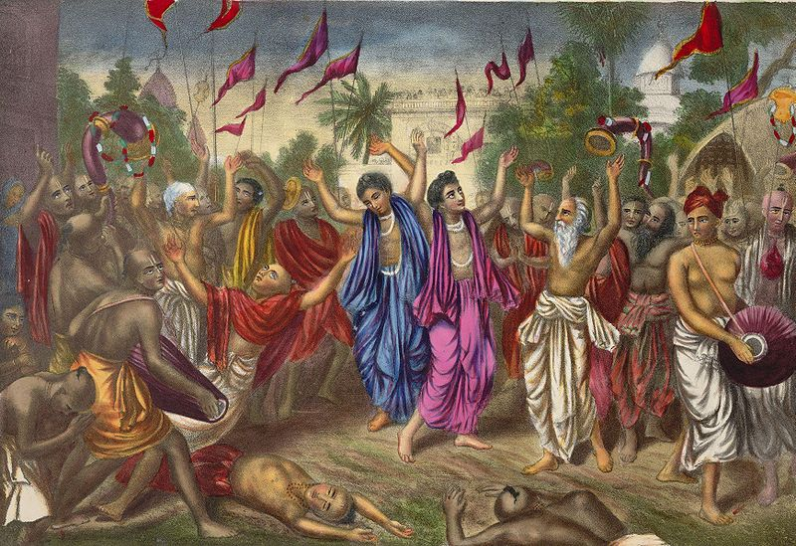
Lord Sri Krishna Chaitanya Mahaprabhu conducting Harinam Sankirtan along with His confidential associates.

- The reason why Krishna does not immediately reciprocate
From Srila Vishvanath Chakravarti Thakura (VCT) Sarartha Darsini Tenth canto commentaries:
Purport to Text 10.32.20:But the reason I do not immediately reciprocate the affection of living beings even when they worship Me, O gopīs, is that I want to intensify their loving devotion. They then become like a poor man who has gained some wealth and then lost it, and who thus becomes so anxious about it that he can think of nothing else.
Srila VCT writes:
Krsna says: For those surrendered souls who worship Me through nama-kirtana and other means, I do not respond in order to make their worship more perfect. O Gopis(abala-gana) who cannot understand My real intention.! Not seeing Me, those surrendered souls develop deep humility, feeling, 'Alas, alas, everything I have done has been useless. Because I am offender, Krsna has not shown even the slightest favor toward me. Let me be damned!"
"By constantly thinking in this way, those who have not yet developed mature love for Me will become free from lust and anger and awaken pure devotion full of power and brilliance. However, the nature of those who already have nature love(krsna-prema) for Me is different. For them, I do not respond in order to increase their attachment to Me. I appear and then disappear, in order to deepen their loving attachment."
"In this way I am actually merciful. It is desirable for My worshipers to have this complete attachment to Me. Thus to increase that attachment more and more, I, even though externally failing to reciprocate very much with them."
"Although you gopis are the ideal examples of those who worship even those who do not worship them, I too am actually very merciful, as muh as you are, since I have given you the gift of my darsana. One should not think that only if I am present that I respond, and if I am absent I do not respond. For then my promise ye yatha mam prapadyante tams tathaiva bhajamy aham, 'I will respond accordingly as they worship Me'(BG 4.11) would be broken"
Hare Krishna!

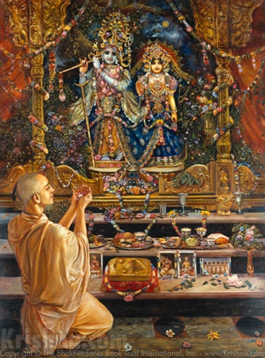
“A leaf, flower, fruit or even a little water when offered with love and devotion, I accept it” says Krishna in BG 9.26.
- How To Offer Bhog.
Any activity when directed as a service to Krishna, it becomes devotional service. This is the potency of Krishna Consciousness. Even seemingly mundane work like eating, singing, dancing, cooking, drawing/painting, earning money, travelling, speaking, etc when directed towards serving Krishna and satisfying Krishna instead of our own material senses, they become purified, spiritual and take the form of devotional service. A devotee even though engaged in all sorts of activities, is not entangled by the fruits of those activities since the fruits are surrendered to Krishna. Therefore, unlike the mayavadis who want to renounce all work considering it to be material, the devotees of the Lord who are engaged in serving the Lord are not increasing their karma, rather they are performing akarma (actions which bear no fruits good or bad) and they are satisfied simply by seeing Krishna satisfied by their services.
Cooking is a very essential activity. Srila Prabhupada says “Cooking does not mean simply making a preparation to satisfy one’s hunger. It means to make a preparation which creates hunger even if one is not hungry. Cooking is an art.” When this art of cooking is directed towards serving Krishna, it becomes a spiritual activity and takes the form of devotional service. Ordinarily people cook food in order to satisfy their own hunger or that of their family and friends etc. But this is selfish cooking. According to the Vedic version bhajante te tv aghama papa ye pachanty atma karanat “those who cook food for their personal sense gratification are eating only sin.” Therefore whatever food one prepares it must be first offered to Krishna as bhoga and later it must be distributed among everyone as Maha Prasadam. However, here a special care must be taken not to offer any non vegetarian items to Lord Krishna (including onion, garlic and masoor dal- red lentils since they are considered non veg in a strict sense). The food prepared must be pure vegetarian. Also one must observe the highest standards of cleanliness, hygiene and purity while preparing and offering food (bhog) to Krishna. The food being offered must be accompanied by a Tulsi leaf. While offering bhog, one must pray “My dear Lord Krishna, I have prepared this humble offering for You with Love and Devotion. Please be merciful on me and kindly accept this offering.” One may keep the offering in front of a picture or deity of Lord Krishna and offer bhog. If a picture or deity are not available, then one may pray to Krishna in his heart for accepting the bhog. It is a good practice to maintain a separate set of plate, cups, spoon and glass for making offerings to Krishna. One must be careful not to eat Prasadam in front of the deities, in the Temple room or in the Kitchen. Having eaten prasadam, one must immediately clean the place where Prasadam was eaten, and also wash the dishes in which prasadam was eaten.
But what is the benefit of observing these rules and regulations and offering bhog to Krishna and eating Krishna Prasadam? In the 5th chapter of the 1st canto of Srimad Bhagavatam, Srila Narada Muni narrates the story about his previous life to his disciple Vedvyasa. He tells him that in his previous birth he was the son of a very poor woman and he had no educational qualifications. His mother would serve the Brahmins and Sanyasis who would come to their village to stay during the four months of caturmasa (July to October). Narada Muni would serve food to the Sanyasis and with their permission, would eat the remnants from their plates. By gradually doing so, the seed of devotion was planted in his heart and renouncing material life he began his search for the Absolute Truth. Being pleased with his sincerity and austerity Lord Krishna revealed His form to him and thereafter he was born as the son of Brahma and became one of the topmost devotees of Lord Sri Krishna. Thus, by offering bhog to Krishna and eating Krishna Prasadam, the seeds of devotion are planted in one’s heart and one gets freedom from material bondage and the mercy of Lord Krishna.
Hare Krishna!

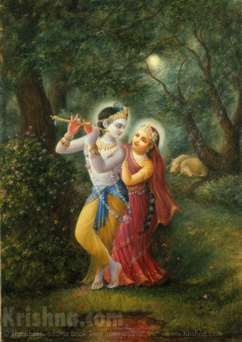

Dedicated at the Lotus feet of Lord Sri Krishna

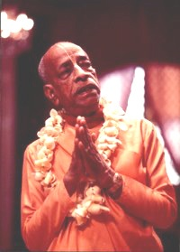
Dedicated to His Divine Grace A.C Bhaktivedanta Swami Prabhupada-Founder Acharya of the International Society for Krishna Consciousness.
Written, Edited, Published and Distributed by,
Rasabihari Das (Vinay Chakraborty)

Send in your questions, views, comments or suggestions to: vinay.chakraborty@yahoo.com

For more information please visit: www.soldiersofgodhead.yolasite.com

Chant Hare Krishna and Be Happy!

